**SE PROJECT**

**AIRLINE MANAGEMENT SYSTEM**

**Gargeyee Dacharla - AP18110010654**

**Sravana Lakshmi Thota - AP18110010607**

**Manideep Kohir - AP18110010637**

**1.    Develop requirements specification for a given problem**

**Software requirements:**

**Frontend:**

* **HTML**
* **CSS**
* **Javascript**
* **Jquery**

**Backend:**

* **PHP**
* **Mysql**

**Hardware requirements:**

**2.Develop DFD Model (Level 0, Level 1 DFD and data dictionary) of the sample problem**

**LEVEL-0:**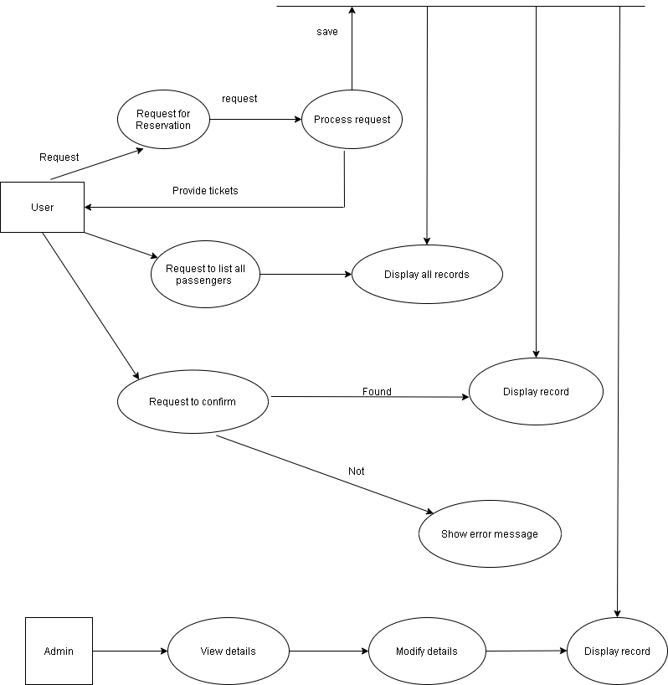

**LEVEL 1**

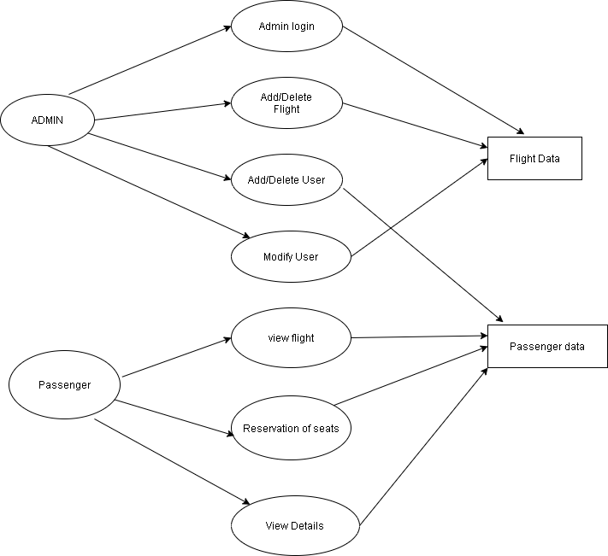

**DATA DICTIONARY**

|  |  |  |  |  |  |
| --- | --- | --- | --- | --- | --- |
| S.NO | ATTRIBUTES | DATA TYPE | FIELD LENGTH | CONSTRAINTS | DESCRIPTION |
| 1 | USERNAME | alpha-numeric | 20 | Primary key | A name that uniquely identifies each user. |
| 2 | PASSWORD | alpha-numeric | 20 | Not Null | Password of the user for secure account. |
| 3 | FROM(PLACE) | string | 20 | Not Null | Place from which the passenger boards the flight |
| 4 | TO(PLACE) | string | 20 | Not Null | Passengers’ Destination |
| 5 | Departure | numeric | 5 | Not Null | Day of departure |
| 6 | Return | numeric | 5 | Not Null | Day that  the passengers want to return |
| 7 | Tickets | numeric | 2 | Not null | Number of tickets |

**3.    To perform the function-oriented diagram: DFD and Structured chart.**

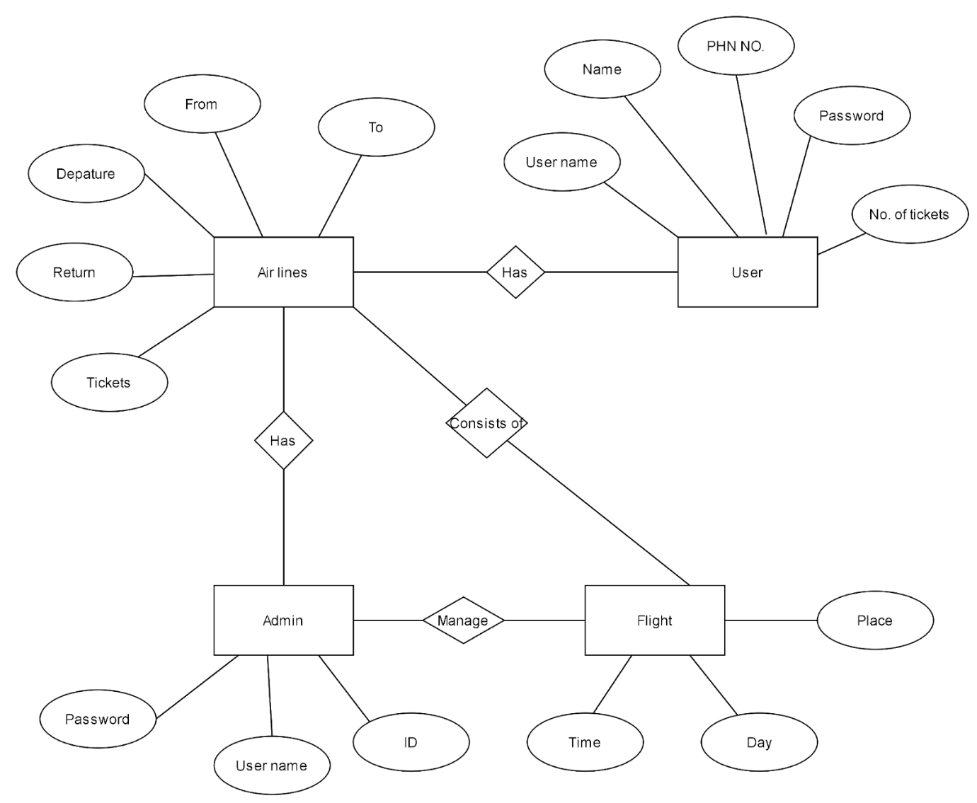

**4.    To perform the user’s view analysis: Use case diagram**

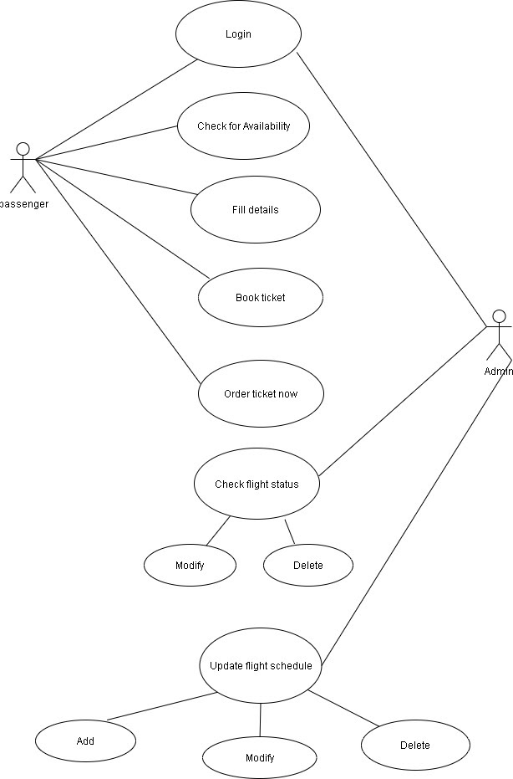

**5.    To draw the structural view diagram: Class diagram, object diagram**

**CLASS DIAGRAM**

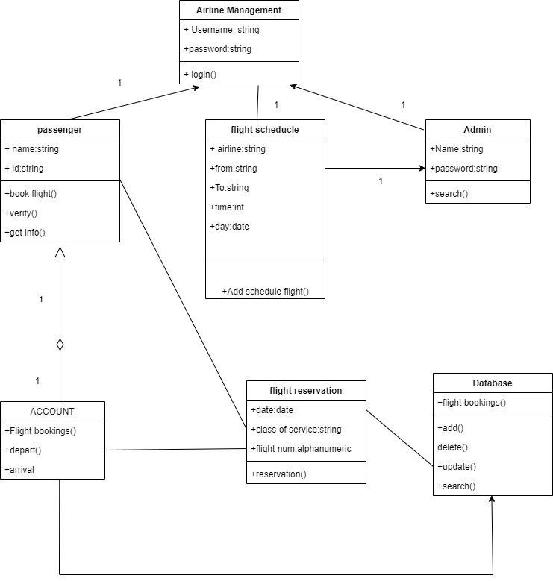

**OBJECT DIAGRAM**

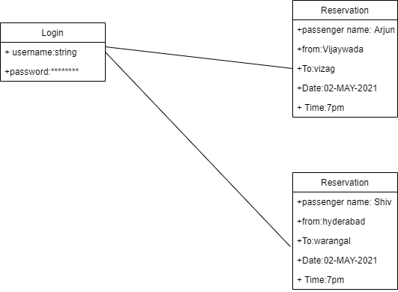

**6.To draw the behavioral view diagram: Sequence diagram, Collaboration diagram**

**a)SEQUENCE DIAGRAM**

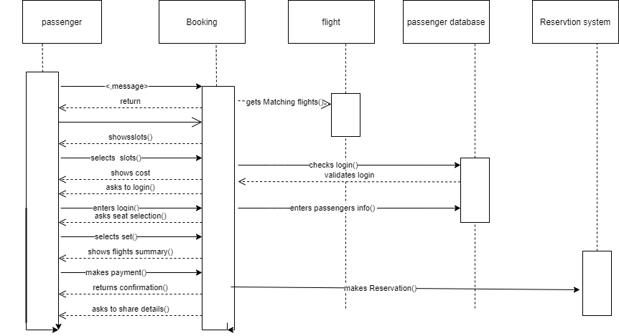

**b)COLLABORATION DIAGRAM**

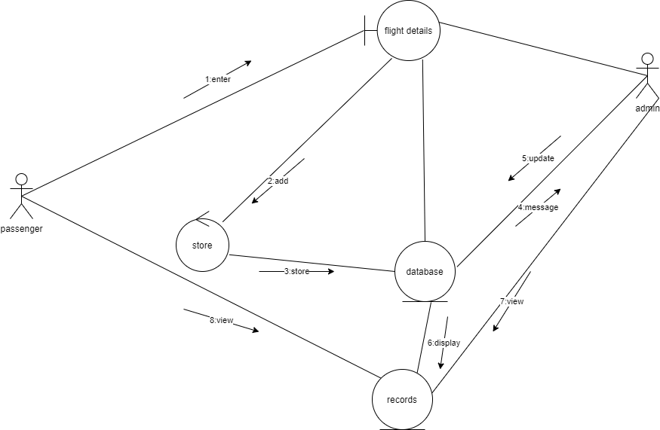

**7.Draw the behavioral view diagram: State-chart diagram, Activity diagram**

1. **State-chart diagram:**

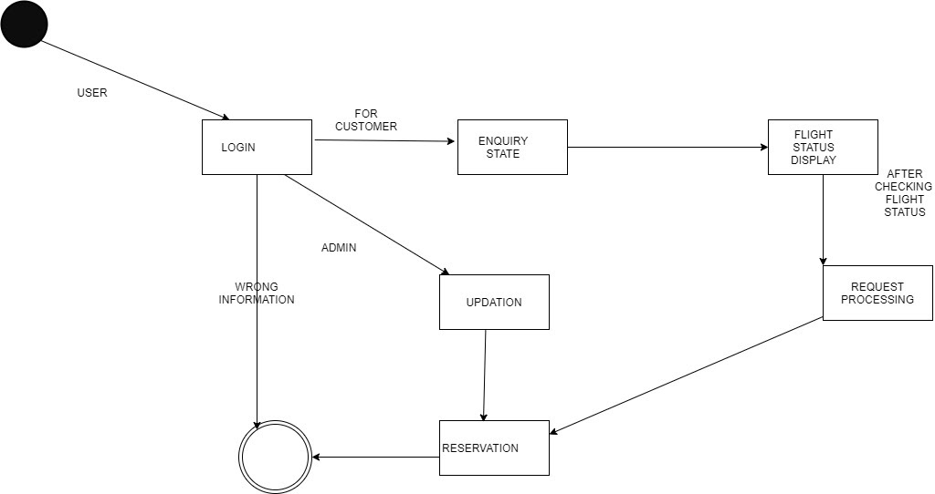

**ACTIVITY DIAGRAM:**

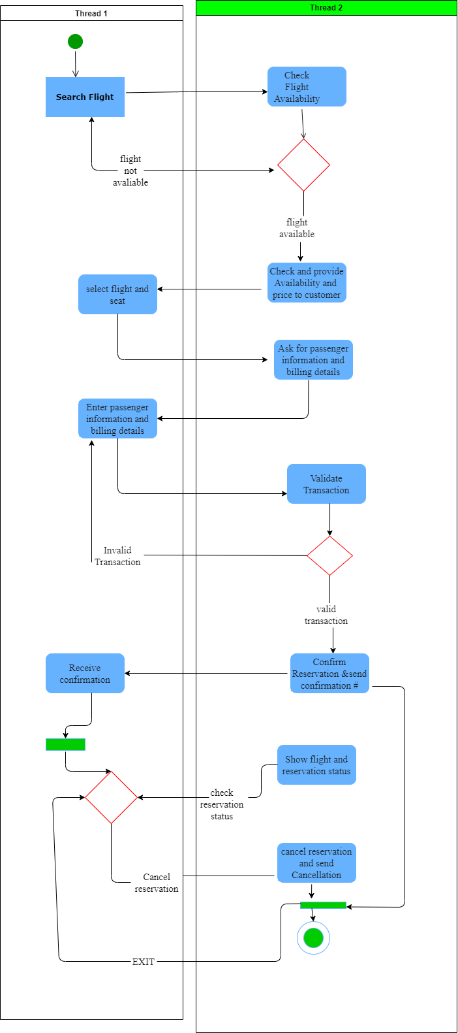

**8.    To draw the implementation view diagram: Component diagram**

**COMPONENT DIAGRAM:**

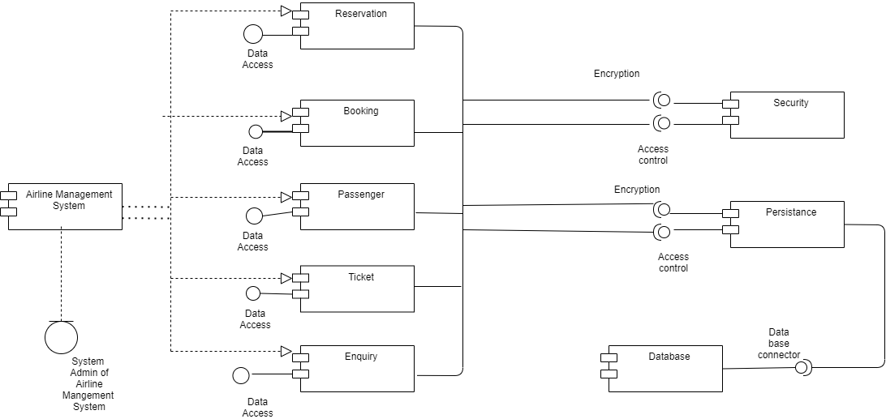

**9.Draw the environmental view diagram: Deployment diagram**

**DEPLOYMENT DIAGRAM:**

